
AMRITA SCHOOL OF ENGINEERING, BENGALURU

DEPARTMENT OF ELECTRONICS & COMMUNICATION ENGINEERING

B. TECH. II SEMESTER ECE AY 2025-2026

23ECE184 INTRODUCTION TO INTERNET OF THING LAB

SYSTEM DESIGN REPORT

MAY 2026

Submitted by

BL.EN.U4ECE25205 | Aravind Sri Ram
BL.EN.U4ECE25206 | Ashith Kiran Reddy
BL.EN.U4ECE25221 | Kandakuri Jayanth

Batch Number:

Faculty Examiner Signature with Date

SMART PARKING SPACE

Objectives:
- To design and implement an automated parking system that can detect vehicle entry and exit using ultrasonic sensors.
- To control entry and exit gates using servo motors based on vehicle detection.
- To assign parking slots (P1, P2) and generate unique passwords for each vehicle via Bluetooth.
- To allow vehicles to exit by verifying the correct password through a MIT App Inventor-based Android application over Bluetooth.
- To display real-time status messages (welcome, slot info, gate status) on an LCD screen.
- To track the number of occupied parking slots in real time.

Components Required:

- Arduino Uno R3
- LCD 16×2
- IR Sensor
- HC-SR04 Ultrasonic Sensor
- Bluetooth Module HC-05
- Breadboard
- Jumper Wires
- Motor
- Potentiometer

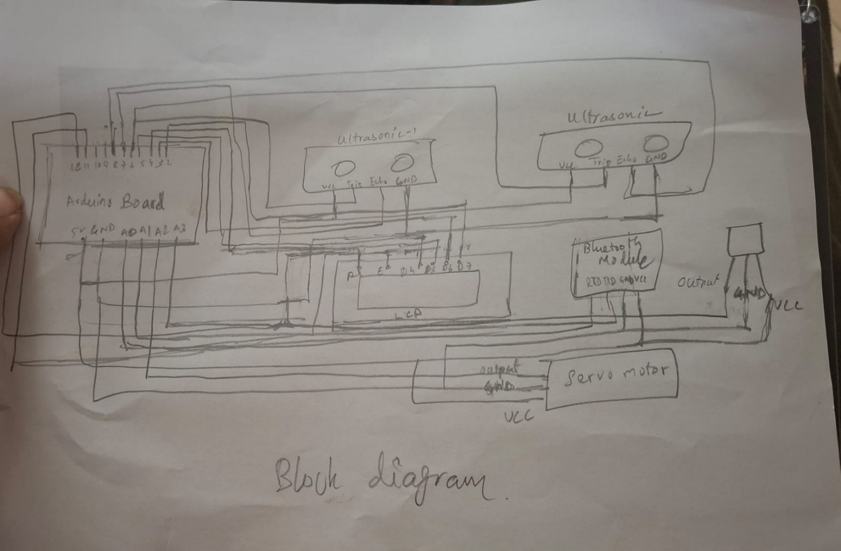
Block Diagram:
(Fig:- This diagram illustrates the architecture of a smart parking system, showing the interaction between the Arduino Uno, sensors (IR and ultrasonic), display unit (LCD), and actuator (servo motor) for real-time vehicle detection, slot monitoring, and automated gate control.)

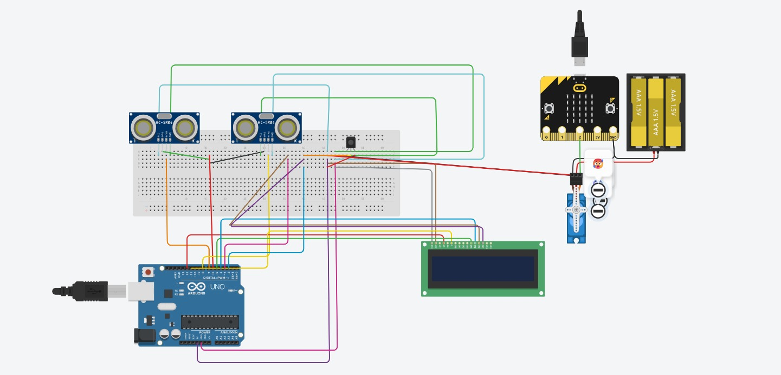
Circuit Diagram:
(Fig:- Circuit diagram of the Smart Parking System. The Arduino Uno (U1) is connected to two HC-SR04 ultrasonic sensors (DIST1, DIST2) sharing a common trigger pin (Pin 6), with echo pins on 7 and 8. Two IR sensors connect to analog pins A2 and A3 for slot detection. Two servo motors are attached to pins 9 and 13 for entry and exit gate control. Two 16×2 LCD displays share data pins (2, 3, 4, 5, 12) with separate enable pins (10, 11). A Bluetooth module is connected via Software Serial on pins A0 (RX) and A1 (TX). The micro:bit with AAA battery pack provides auxiliary power.)

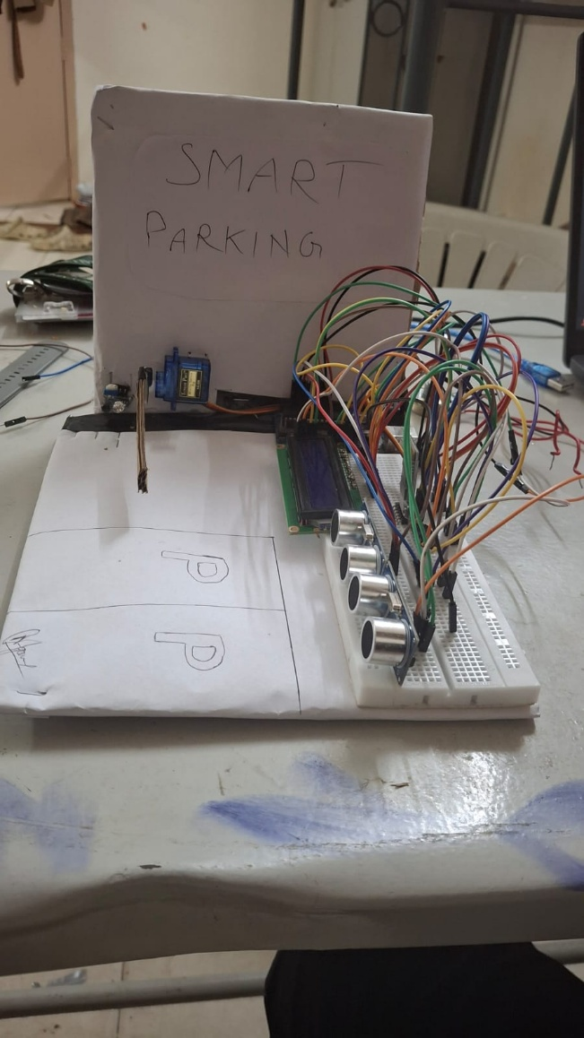
Working Prototype:
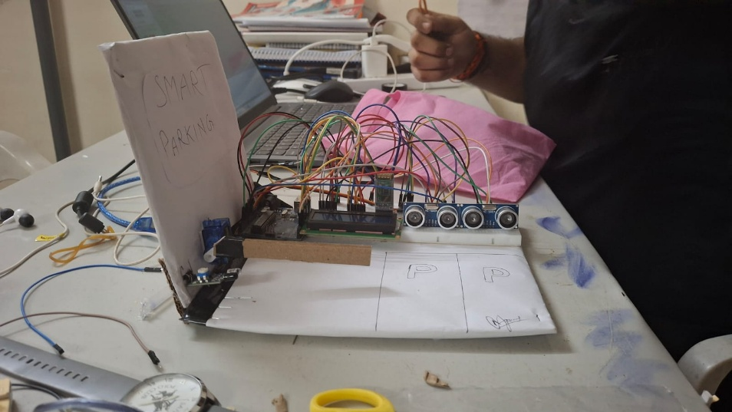
(Fig 1: Front View of Smart Parking System Prototype
This figure shows the front view of the smart parking system prototype, illustrating the arrangement of ultrasonic sensors for vehicle detection, the LCD display for real-time parking information, and the breadboard-based circuit connections integrated with the Arduino Uno)
(Fig 2: Side View of Smart Parking System with Entry Gate Mechanism
This figure presents the side view of the prototype, highlighting the servo motor-based automated entry gate, IR sensor placement for vehicle detection, and the structural layout of the parking slots.)

(Fig3: Top View of Smart Parking System Prototype
This figure shows the top view of the smart parking system prototype, illustrating the complete circuit layout including the Arduino Uno, LCD display module, ultrasonic sensors, and connecting wires on the breadboard. It also highlights the parking slot markings and overall system integration for real-time vehicle detection and monitoring.)

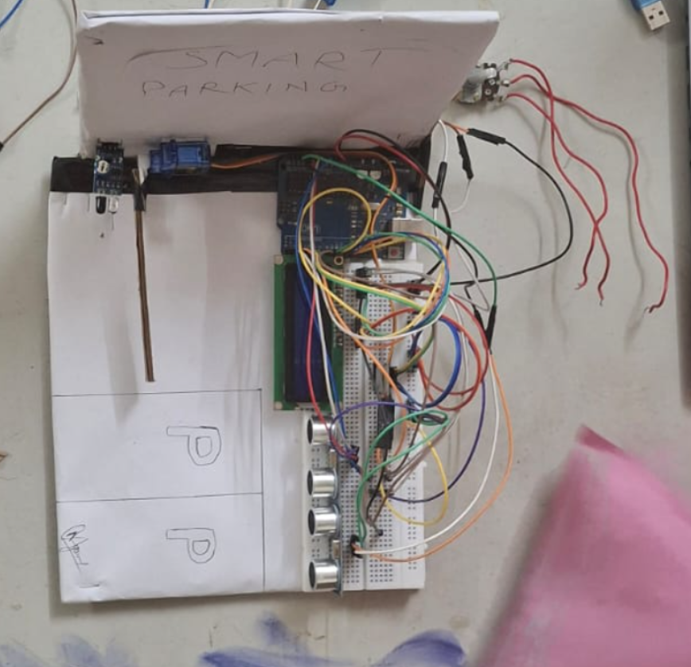

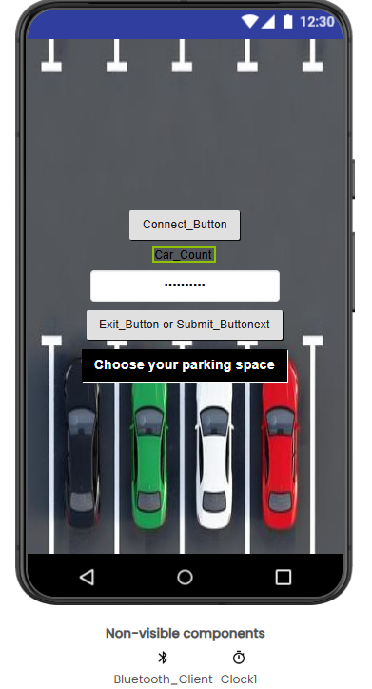
MIT App Screenshots:
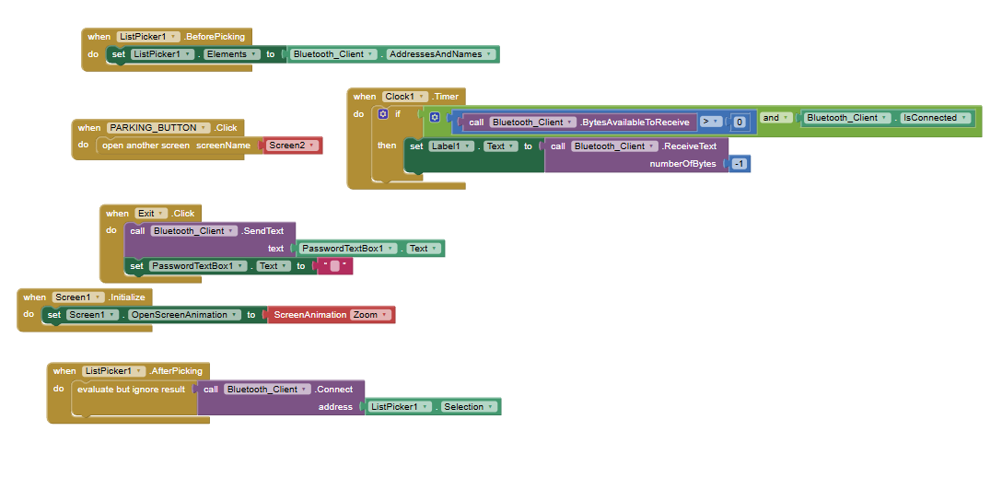
Screen1-
(Fig: Mobile Application Interface and Block Programming for Smart Parking System
This figure illustrates the mobile application developed for the smart parking system along with its underlying block-based programming in MIT App Inventor. The interface provides features such as Bluetooth connectivity, real-time car count display, and parking space selection, while the programming blocks demonstrate the logic for device connection, data transmission, and real-time monitoring of parking availability.)

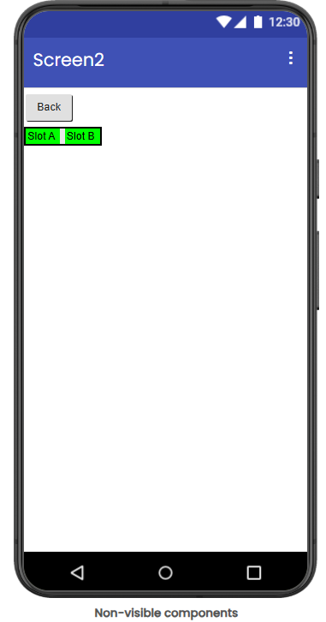
Screen 2-

(Fig: Parking Slot Selection Interface and Control Logic in Mobile Application
This figure illustrates the parking slot selection screen of the mobile application along with its corresponding block-based programming in MIT App Inventor. The interface displays available parking slots (Slot A and Slot B) and provides navigation controls, while the programming logic demonstrates real-time data reception via Bluetooth and dynamic updating of slot status using color indicators based on availability.)

Flowcharts
MIT app
Flowchart for MIT App Inventor Blocks
┌───────────────────────────────┐
│ App Starts │
└──────────────┬────────────────┘
│
▼
┌───────────────────────────────┐
│ Screen1.Initialize │
│ Set Screen Animation = Zoom │
└──────────────┬────────────────┘
│
▼
┌───────────────────────────────┐
│ ListPicker1.BeforePicking │
│ Load Bluetooth Devices List │
└──────────────┬────────────────┘
│
▼
┌───────────────────────────────┐
│ User Selects Device │
└──────────────┬────────────────┘
│
▼
┌───────────────────────────────┐
│ ListPicker1.AfterPicking │
│ Connect Bluetooth Client │
└──────────────┬────────────────┘
│
▼
┌───────────────────────────────┐
│ Clock1.Timer │
│ Check Bluetooth Connection │
└──────────────┬────────────────┘
│
┌─────────▼─────────┐
│ Bytes Available ? │
└───────┬───────────┘
│Yes
▼
┌───────────────────────────────┐
│ Receive Bluetooth Text │
│ Display on Label1 │
└──────────────┬────────────────┘
│
▼
┌───────────────────────────────┐
│ PARKING_BUTTON.Click │
│ Open Screen2 │
└──────────────┬────────────────┘
│
▼
┌───────────────────────────────┐
│ Exit.Click │
│ Send Password Text via BT │
│ Clear Password Textbox │
└───────────────────────────────┘

Flowchart for Arduino Smart Parking Code
┌───────────────────────────────┐
│ START │
└──────────────┬────────────────┘
│
▼
┌───────────────────────────────┐
│ Setup Function │
│ - Initialize Serial │
│ - Initialize Bluetooth │
│ - Configure Pins │
│ - Attach Servo │
│ - Initialize LCD │
└──────────────┬────────────────┘
│
▼
┌───────────────────────────────┐
│ LOOP() │
└──────────────┬────────────────┘
│
▼
┌───────────────────────────────┐
│ Read Ultrasonic Sensors │
│ Measure Distance for Slots │
└──────────────┬────────────────┘
│
▼
┌───────────────────────────────┐
│ Determine Slot Status │
│ Slot Occupied or Free │
└──────────────┬────────────────┘
│
▼
┌───────────────────────────────┐
│ Calculate Free Slots │
└──────────────┬────────────────┘
│
▼
┌───────────────────────────────┐
│ Update LCD Display │
│ Show Slot Availability │
└──────────────┬────────────────┘
│
▼
┌───────────────────────────────┐
│ Send Status via Bluetooth │
│ and Serial Monitor │
└──────────────┬────────────────┘
│
▼
┌───────────────────────────────┐
│ Read IR Sensor │
│ Detect Car at Entry │
└──────────────┬────────────────┘
│
┌─────────▼──────────┐
│ Car Detected ? │
└───────┬─────────────┘
│Yes
▼
┌───────────────────────┐
│ Free Slots Available? │
└───────┬───────────────┘
│Yes
▼
┌───────────────────────────────┐
│ Open Barrier Servo │
│ Display Welcome Message │
│ Send Gate Open Status │
└──────────────┬────────────────┘
│
▼
┌───────────────────────────────┐
│ Wait 3 Seconds │
└──────────────┬────────────────┘
│
▼
┌───────────────────────────────┐
│ Continue Loop │
└───────────────────────────────┘

NO
▼
┌───────────────────────────────┐
│ Parking Full │
│ Keep Barrier Closed │
│ Display FULL Message │
│ Send No Entry Status │
└──────────────┬────────────────┘
│
▼
┌───────────────────────────────┐
│ Wait 1.5 Seconds │
└──────────────┬────────────────┘
│
▼
┌───────────────────────────────┐
│ Continue Loop │
└───────────────────────────────┘

NO CAR DETECTED
▼
┌───────────────────────────────┐
│ Close Barrier if Open │
│ Send Gate Closed Status │
└──────────────┬────────────────┘
│
▼
┌───────────────────────────────┐
│ Delay 500 ms │
└──────────────┬────────────────┘
│
▼
┌───────────────────────────────┐
│ Repeat LOOP() │
└───────────────────────────────┘

Simple Explanation
MIT App Inventor Flow
- App starts and initializes the screen.
- Bluetooth devices are loaded into the ListPicker.
- User selects a Bluetooth module.
- App connects to the Bluetooth module.
- Clock continuously checks for incoming Bluetooth data.
- Received parking data is displayed on the screen.
- Parking button opens another screen.
- Exit button sends password text through Bluetooth.

Arduino Smart Parking Flow
- System initializes LCD, Bluetooth, sensors, and servo motor.
- Ultrasonic sensors detect parking slot occupancy.
- LCD displays free and occupied slots.
- Bluetooth sends parking status to the mobile app.
- IR sensor checks if a car is at the entry gate.
- If slots are available, the gate opens.
- If parking is full, entry is denied.
- Gate closes automatically after vehicle movement.
- Process repeats continuously.

GitHub Link
https://github.com/Jayanth-07-coding/IoT-System-Level-design

References

Arduino Official Documentation:
https://www.arduino.cc/reference/en/HC-SR04 Ultrasonic Sensor Datasheet
MIT App Inventor Documentation: https://ai2.appinventor.mit.edu/
LiquidCrystal Library: https://www.arduino.cc/en/Reference/LiquidCrystal
Servo Library: https://www.arduino.cc/en/Reference/Servo
SoftwareSerial Library: https://www.arduino.cc/en/Reference/SoftwareSerial

